American International University-Bangladesh Department of Electrical and Electronic Engineering EEE3120: Digital Logic &Circuits Laboratory

Title: Design and implementation of multivibrators using Timer IC

# Introduction:

The name of the timer comes from the three 5 kΩ resistors which are embedded in it [1]. This IC gives precise time at the output which is must in the time related circuits. One of its basic operations is to produce clock pulses with predefined frequency as an astable mutivibrator. Another operation is to work like a stop watch which is done in monostable mode. We will see these two operations in this experiment. The following figure is the layout of the 555 Timer IC as which allows us to focus on the functions of the circuit.

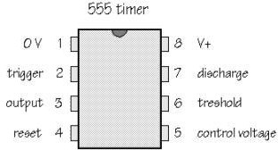

**Figure 1**: Pin configuration of the 555 timer IC.

# Theory and Methodology:

**Astable Multivibrator:** It is also called free running sinusoidal oscillator. An astable multivibrator is simply and oscillator. The astable multivibrator generates a continuous stream of rectangular off-on pulses that switch between two voltage levels. The frequency of the pulses and their duty cycle are dependent upon the RC network values.

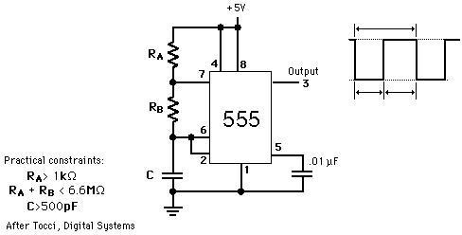

**Figure 2:** 555 timer connected as an astable multivibrator

The time that the output is high, TL is how long it takes C to discharge from 1/3 of Vcc to 2/3 of Vcc. It is expressed as

TH = 0.7(RA + RB) C

The time that the output is low, TH is how long it takes C to charge from 2/3 of Vcc to 1/3 of Vcc. It is expressed as

TL =0.7RBC

The time period, T = TH + TL = 0.7(RA + 2RB) C Frequency of Oscillation, f = 1/T = 1.44 / (RA + 2RB) C Duty cycle, D = TH/ T = (RA + RB)/ (RA + 2RB) x 100%.

**One shot multivibrator:** In the one-shot mode, the 555 acts like a monostable multivibrator. A monostable is said to have a single stable state--that is the off state. Whenever it is triggered by an input pulse, the monostable switches to its temporary state. It remains in that state for a period of time determined by an RC network. It then returns to its stable state. In other words, the monostable circuit generates a single pulse of fixed time duration each time it receives and input trigger pulse. Thus the name becomes one-shot. One-shot multivibrators are used for turning some circuit or external component on or off for a specific length of time. It is also used to generate delays. When multiple one-shots are cascaded, a variety of sequential timing pulses can be generated. Those pulses will allow you to time and sequence a number of related operations.

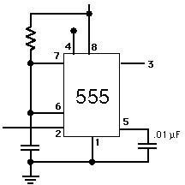Pulse width of the output is given by T= 1.1 RC (in seconds)

**Figure 3**: 555 timer connected as a one shot multivibrator

# Pre-Lab Homework:

Students should take the simulation results of the circuits given in the lab sheet using any standard software like PSPICE, Proteus, and Circuit Maker etc.

|  |  |
| --- | --- |
| **Apparatus:** |  |
| Resistors 1k | 1[pcs] |
| Resistors 2.2k | 1[pcs] |
| Resistors 4.7k | 1[pcs] |
| Resistor 50k | 1[pcs] |
| Capacitor 0.01u | 1[pcs] |
| Capacitor 0.022u | 1[pcs] |
| Capacitor 100u | 1[pcs] |
| 555 Timer IC | 1[pcs] |
| **Precautions:** |  |

Never turn on the DC source before the circuit is placed correctly and checked carefully. Check for short circuits in the circuit.

# Experimental Procedure:

The setups for the astable multivibrator and monostable multivibrator are given in the following figures.

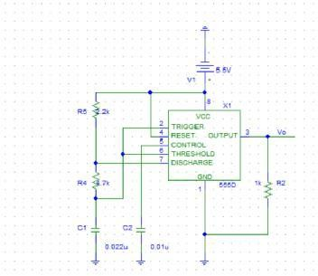

**Figure 4**: Experimental setup for astable multivibrator.

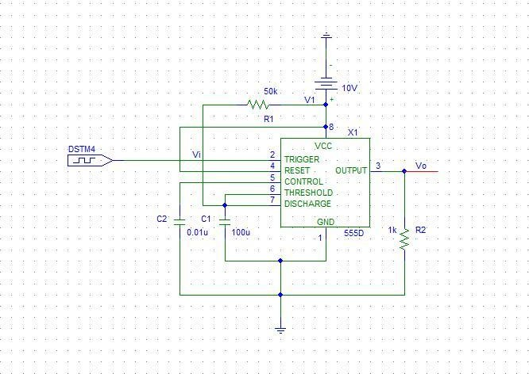

**Figure 5:** Experimental setup of the monostable multivibrator.

# Result and Findings:

After completing the experiment, the student will take the wave-shapes found in the experiment. They will take all the numerical data like magnitude of the output, time/duration as high, time/duration as low. They will match the result with the formulae.

# Reference(s):

1. Boylestad, Robert L., and Louis Nashelsky. *Electronic Devices And Circuit Theory*, 2006, Pearson Prentice Hall.
2. Thomas L. Floyd, *Digital Fundamentals*, 9th Edition, 2006, Prentice Hall.